 |  |  |  |   Sarah Bell

St. Charles County Association of REALTORS®
SCCAR President 2025
SCCAR President-Elect 2024
SCCAR Board of Director 2022-2025
SCCAR Events Co-Chair 2022 & Chair 2023
SCCAR Finance Committee 2023-2025
SCCAR Strategic Planning Committee 2021- 2023
SCCAR Salesperson Nominating Committee 2022-2023
SCCAR Salesperson Nominating Chair 2021
SCCAR Government Affairs 2021
SCCARPAC Committee member 2021
SCCAR Events Committee member 2020-2021, 2024

SCCAR Commercial Member 2021-2026
YPN Advisory Board 2022, YPN Task Force 2026
SCCAR Leadership Academy Graduate 2021

St. Charles County REALTOR® Salesperson of the Year 2020

Missouri Association of REALTORS®
MO Risk Management Committee Member 2022-2023
MO State Director 2021-2026
MO Specialty Output Groups Vice-Chair 2024
MO Specialty Groups Chair 2025 Task Force utilization
Honor Society 2022-2025

Women’s Council of REALTORS® St. Charles County
WCR STC member August 2018
WCR STC member 2019
WCR STC Secretary 2020
WCR STC President Elect 2021
WCR STC President 2022
WCR Standing Rules Task Force 2023-2024
WCR Parliamentarian 2024
WCR Member of the Year 2024
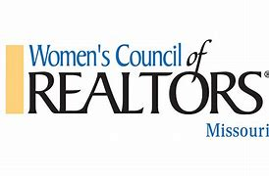


Women’s Council of REALTORS® Missouri
WCR State Nominating Committee 2021
Missouri ExCEL Award Winner 2021
State Events Chair 2023
Entrepreneur of the Year Award Winner 2023
WCR State Treasurer 2024
Strategic Planning Committee 2024
First Vice President 2025
President Elect 2026
LID Committee member 2026

Women’s Council of REALTORS® National
Attended National Conference San Diego Nov 2021
Attended National Conference Orlando Nov 2022
Attended National Mid-Year Washington, DC 2024
Attended National Conference Boston, MA 2024
Attended National Mid-Year Washington, DC 2025
National Leadership Institute 2026

Regional Support Roles
MARIS Credentialing Committee October 2025

REALTOR® Political Action Committee
Major Investor Sterling R 2019-2023
Major Investor Crystal R 2024-2026

Education
NAR C2EX Endorsement April 2021-current, renewed in April 2024
NAR At Home with Diversity Designation April 2021
WCR PMN Designation April 2021
Missouri Notary 2022-2030

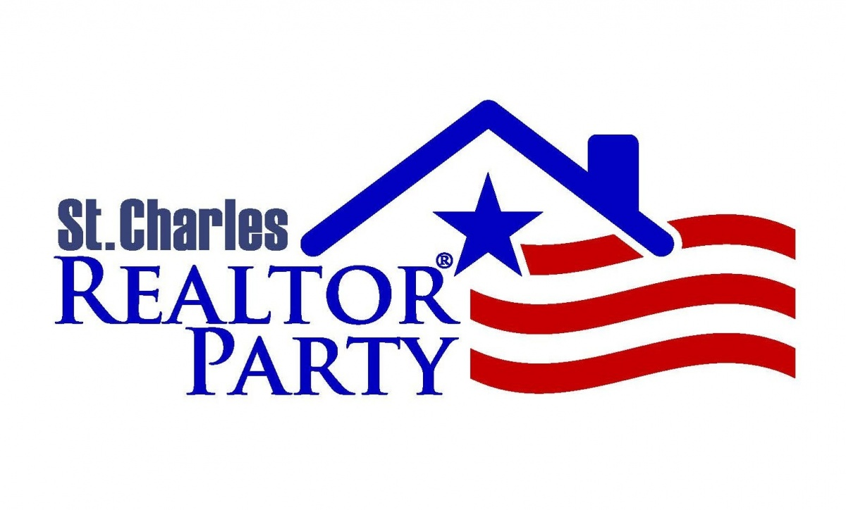
Community
Wentzville Rotary- member 2023-2026

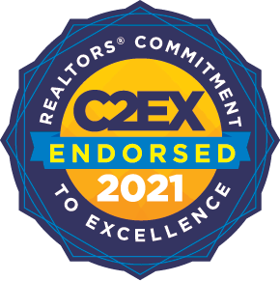
Referrals
Received FL referral – May 2017
6738 Vernon Ave., St . Louis, MO

Received local referral- March 2021

122 Ridgecrest, Troy, MO

Sent GA referral- February 2022
118 Lee Street, Statesboro, GA

Received referral- June 2023
2915 Ehlmann Rd., St. Charles, MO
From WCR KC lead-Lin Van Meter

Referral received- May 2024
800 Sugar Valley Ct., St. Peters, MO 63376
From MO Realtors- Lenora Kay

Referral received- June 2024
4525 Laclede Ave. #15, St. Louis, MO 63108
From WCR AZ- Teresa Meek

Referral sent- April 2026
2042 St Paul 2nd St, Saint Paul, IA 52657
WCR Connection

Referral received- July 2026
4104 Bridgeton Meadows Ct., Bridgeton, MO 63044
IL Realtor

Referral sent- August 2026
4613 Valleydale Dr., Godfrey, IL 62035
WCR Connection

127 Mulberry Street
Foristell, MO 63348
 |  | 636.614.8693
 |  | GoldBellRE@gmail.com

